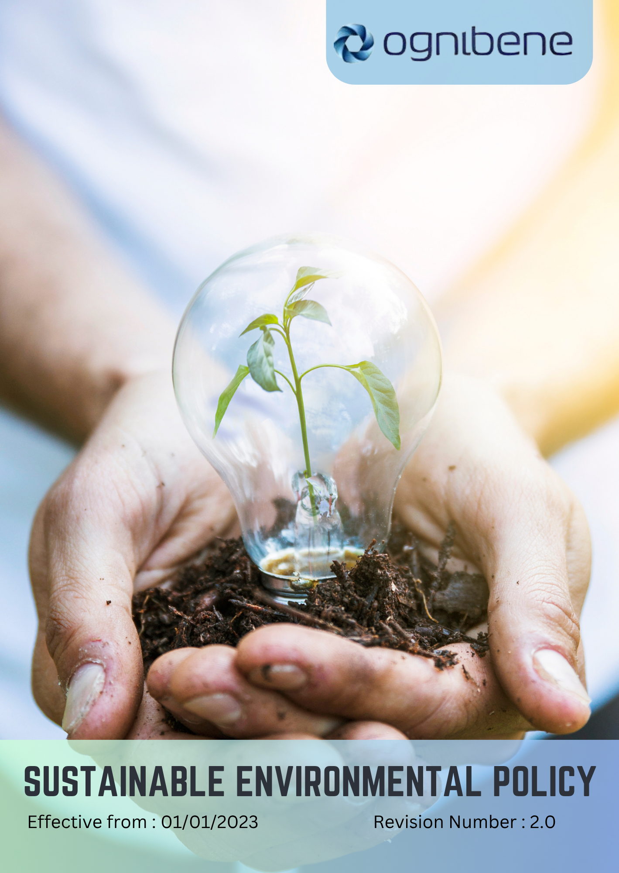

TABLE OF CONTENTS

Introduction 3
Scope 3
Policy Statement 3
Key Focus Areas 4
SDGs Covered 6
Responsibility 6
Review Mechanism 7
Revision History 7
Acknowledgement 8

Introduction
OGNIBENE INDIA PVT LTD, incorporated on February 10, 2006, is dedicated to designing and manufacturing hydraulic cylinders and hydraulic steering systems for off-highway vehicles, automotive, and marine applications. We are committed to environmental stewardship, ensuring that our operations and products contribute positively to sustainability. We are committed to sustainable practices that minimize our environmental impact and promote the well-being of our customers and the community. This policy outlines our approach to environmental management of operations and products, focusing on key sustainability issues such as energy consumption, greenhouse gas emissions, water usage, air pollution, materials, chemicals, waste, product use, and product end-of-life.

Scope
This policy applies to all workers, employees, directors, officers, agents, contractors, and any third parties acting on behalf of OGNIBENE INDIA PVT LTD, (OIL). It covers all business activities, including procurement, sales, marketing, and any interactions with government officials, customers, suppliers, and other stakeholders. The policy is applicable globally, regardless of local business practices or cultural norms. This policy applies to below mentioned locations:
Unit 1: | Ognibene India Private Limited – Pune Plant (I)  Plot A-13 Talegaon MIDC Village Ambi Navlakh Umbhre Talegaon, Pune Maharashtra – India
Unit 2: | Ognibene India Pvt. Ltd.  Unit No. A, B-600, Plot No.8, Ishanvi Industrial & Logistics 140402 Park, Vividha Ind.Park, Chamaru, Rajpura Patiala – Punjab – India

Policy Statement
Ognibene India Pvt Ltd. is dedicated to minimizing our environmental impact through effective management of operations and products. This includes reducing energy consumption and greenhouse gas (GHG) emissions, responsible water management, minimizing air pollution, managing materials and waste, and advocating for sustainable practices among our customers.

Key Focus Areas
Below are our commitments and targets towards environmental sustainability as compared to baseline year 2023.

- Energy Optimization & GHG Mitigation
Commitment: We are committed to reducing overall energy consumption and minimizing GHG emissions across all operations by improving energy efficiency and integrating sustainable practices. By optimizing machinery, LED lighting, and digital energy monitoring we reduce overall energy consumption by 25% by 2030, using 2023 as the baseline year, and achieve a 20% reduction in Scope 1, Scope 2 and scope 3 GHG emissions by 2030.

- Renewable energy
We are committed to increasing renewable energy usage to strengthen the sustainability of our operations. By expanding solar rooftop installations and procuring certified green electricity we achieve 35% renewable energy share of total consumption by 2030.

- Water Stewardship
Commitment: We are committed to the responsible management of water resources to protect local water supplies and reduce pollution by Lowering the water consumption by 10% by 2030 compared to the baseline year 2023 levels, and decrease water pollution incidents by 50% by 2030. Effluent treatment and monitoring will maintain 100% compliance and zero discharge violations by 2030. By implementing rainwater harvesting we reduce water consumption by 10% by 2030

- Air Quality Improvement
Commitment: We aim to improve local air quality by minimizing emissions of non-GHG air pollutants, targeting a 25% reduction in emissions of SOx, NOx, VOC, and PM by 2030, while also limiting instances of non-compliance with air quality regulations to less than 2% of total operations.

- Waste Minimization & Management
We are committed to minimizing waste generation and enhancing our waste management practices by promoting recycling and responsible disposal. By implementing zero-waste initiatives, improved segregation, and vendor take-back programs we reduce total waste generation by 40% by 2030 and increase recycling of non-hazardous waste to 65% by 2030. By monitoring waste streams and training employees we ensure efficient waste handling and compliance by 2030.

- Sustainable Product Lifecycle Management
Commitment: We are committed to designing products that are environmentally sustainable throughout their lifecycle, from production to disposal. By designing modular and recyclable products and implementing take-back programs we ensure 85% of products are sustainable by 2030 and reduce emissions and disposal impacts by 45% by 2030. By evaluating product materials and end-of-life solutions we continuously enhance product sustainability by 2030.

- Product Use Efficiency
Commitment: We are committed to enhancing the energy efficiency and environmental performance of our products during their use phase. By optimizing hydraulic system designs and integrating smart flow control components we improve product energy efficiency by 30% by 2030. By conducting performance testing and operational monitoring we ensure products operate at peak efficiency and minimize environmental impact by 2030.

- Environmental Outreach & Customer Engagement
Commitment: We are committed to promoting sustainable practices among our customers through outreach and education by launching at least two sustainability awareness programs annually and achieve a 40% participation rate among customers in these initiatives by 2030.

- Ecosystem Conservation
Commitment: We are dedicated to conserving local ecosystems and biodiversity by conducting biodiversity assessments and implement measures to mitigate impacts on local habitats, aiming for a 50% reduction in negative impacts by 2030. The company targets 27% vegetation coverage by 2030, including 2,000 native tree plantations and conservation of local species around Pune and Punjab facilities

- Responsible Sourcing Practices
Commitment We are committed to sourcing materials responsibly by ensuring suppliers adhere to defined sustainability criteria. By conducting supplier audits, sustainability assessments, and providing guidance on ESG improvements we ensure 100% of suppliers meet sustainability standards by 2030. By integrating supplier engagement and monitoring programs we strengthen sustainable procurement by 2030.

- Employee Participation in Sustainability Initiatives
Commitment: We are committed to fostering a culture of environmental responsibility within our workforce by providing environmental training to 100% of employees by 2030 and encourage their participation in sustainability initiatives.

- Customer Health & Safety
Commitment: We are committed to ensuring our products are safe and environmentally responsible for customer use. By performing rigorous product safety testing, using environmentally safe materials, and implementing operational controls we maintain 100% compliance with customer health and safety regulations by 2030. By monitoring product performance and integrating eco-conscious practices we minimize environmental impacts during product use by 2030.

- Regulatory Compliance & Continuous Enhancement
Commitment: We are dedicated to adhering to all applicable environmental regulations and continuously improving our practices and achieve 100% compliance with environmental regulations by 2030 and conduct annual internal audits to identify areas for improvement.

SDGs Covered
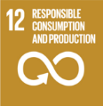
OIL is committed to achieve the following Sustainable Development Goals:
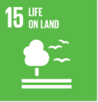

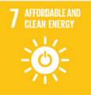
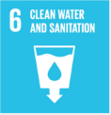

Responsibility
At OGNIBENE INDIA PVT LTD, the responsibility for implementing and monitoring this policy falls to the Environmental Compliance and the Safety Officer. The Environmental Manager oversees adherence to environmental regulations and the overall sustainability strategy, while the Safety Officer ensures compliance with health and safety standards related to environmental practices. All employees are encouraged to actively contribute to these initiatives.

Review Mechanism
The review of this policy will be conducted every two years by the Environmental Compliance Officer. This process will assess the effectiveness and relevance of the policy, incorporating feedback from employees and stakeholders to enhance our environmental practices.

Revision History
Revision No. | Date | Description of Changes | Approved By
0.0 | 01 Jan 2023 | Initial Policy Draft | General Manager Operations
1.0 | 01 Jan 2024 | Updated Scope and add the Acknowledgement section | General Manager Operations
2.0 | 01 Jan 2025 | Updated Key Focus Areas revised with action-oriented commitments and introduced the Revision History table | General Manager Operations

Approved by: General Manager of Operations
Last Review Date: 01 JAN 2025 Next Review Date: 01 JAN 2027

Acknowledgement
I, ______________________, acknowledge that I have read, understood and agree to adhere to the company’s Sustainable Environment Policy. I recognize the importance of my role in supporting the company's commitment to environmental sustainability and am committed to actively participating in the implementation of this policy. I will strive to incorporate environmentally responsible practices into my daily work activities, comply with all relevant environmental regulations and company policies and support the continuous improvement of our environmental performance.

I understand that my commitment is essential to achieving the company's environmental objectives and fostering a culture of sustainability. I am dedicated to contributing to our shared vision of a sustainable future and demonstrating our dedication to environmental stewardship.

Employee Name:
Employee Signature:

